Right to Life of Adams County
Respect Life Dinner
Tuesday, October 13, 2026
Doors Open: 5:30 p.m.
Dinner: 6:00 p.m.
Quincy Holiday Inn-4821 Oak St
Speaker: Reagan Barklage
Call 217-653-0075 for more information
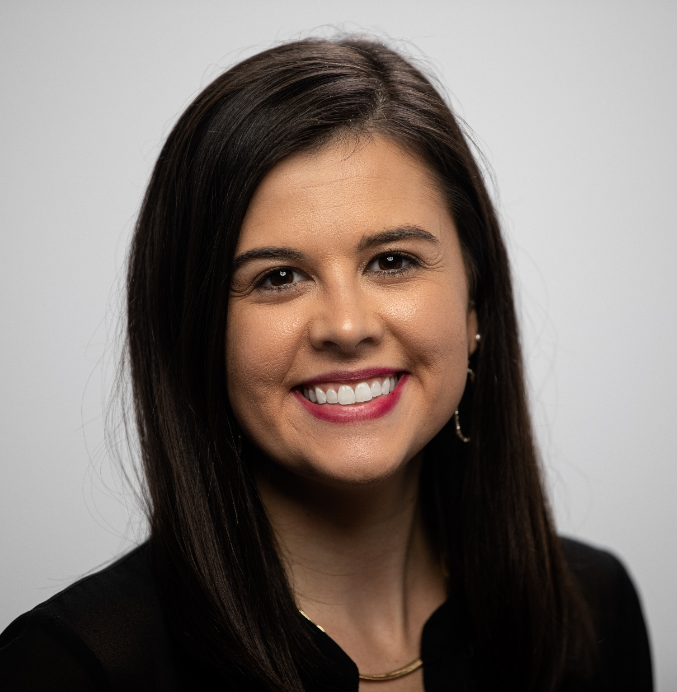

Reagan Barklage grew up all over the United States, as an Air Force brat and graduated from the University of Missouri after studying Journalism. From a young age, Reagan remembers her family praying outside of abortion facilities. A few years later, she was exposed to the graphic truth of abortion by stumbling upon a diagram of a partial-birth abortion and experienced a gut-wrenching passion to respond. During her studies at Mizzou, she founded Mizzou Students for Life and served as President for two years. While serving as President, the group won Students for Life of America’s Best New Group of the Year. Reagan was also accepted into the William Wilberforce Fellowship with Students for Life of America where she further developed leadership skills to help lead the pro-life movement. Since graduation, Reagan has worked full-time in the pro-life movement, dedicating her life to ending abortion. She was accepted into Vita Institute, an intensive training program for pro-life leaders at Notre Dame. Reagan has been featured in Glamour, LifeSiteNews, the HBO documentary Abortion: Stories Women Tell, the Wall Street Journal, and other media outlets. She has spoken at numerous schools, pro-life rallies, and banquets. Reagan now serves as Vice President of Field Programs, overseeing Students for Life of America’s National Field and Leadership Initiatives Teams. She has helped Students for Life grow to almost 1700 groups nationwide. She lives in St Louis with her husband and four young children.

